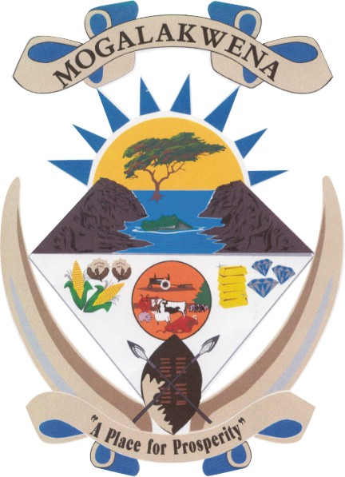
MOGALAKWENA LOCAL MUNICIPALITY
NOTICE OF ADOPTION OF THE FINAL IDP 2020/21 AND FINAL BUDGET 2020/21

In compliance with the provisions of Chapter 5 of the Municipal Systems Act, (Act 32 of 2000) Mogalakwena Municipality hereby gives notice to the public that the Final Integrated Development Plan 2020/21 and Final Budget for the 2020/21 financial year has been adopted by council and that copies thereof are available for public inspection.

This notice informs the public that the Final IDP 2020/21 and Final Budget 2020/21 has been adopted during a virtual council meeting held on the 30 June 2020. Copies of the adopted Final IDP 2020/21 and Final Budget 2020/21 are available at the Municipal Offices for public consumption.

- Civic centre(Municipal Building) 54 Retief Street; office 203/207
- Bakgoma Library, Makobe
- Mokopane Library, Corner Van Riebeck and Pretorius Street, Mokopane
- Mahwelereng Library, 1830 Rufus Seakamela Street, Mahwelereng-A
- Rebone SDA Office
- Diphichi Satellite Office
- Mapela MPCC
- Babirwa MPCC
- Municipal Website – www.mogalakwena.gov.za

These documents can be inspected during office hours from 07h30 to 16h30 or alternatively be viewed from the municipal website.

BS GUNQISA
MUNICIPAL MANAGER
P. O BOX 34
MOKOPANE
0600

Notice No: 03/2020

